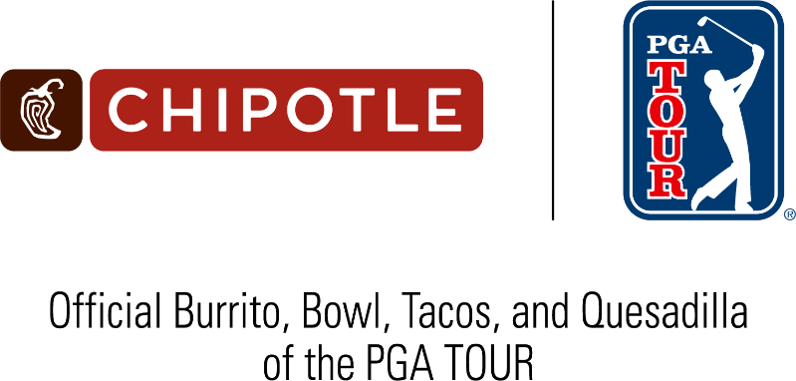

FOR RELEASE: January 7, 2026
CONTACT: Justin Johns, PGA TOUR, justinjohns@pgatourhq.com

PGA TOUR, Chipotle announce new partnership
Chipotle, the leader in Real Food for Real Athletes, becomes the Official Mexican Restaurant, Official Burrito, Bowl, Tacos and Quesadilla of the PGA TOUR and PGA TOUR Champions

PONTE VEDRA BEACH, Florida and NEWPORT BEACH, California – The PGA TOUR and Chipotle Mexican Grill (NYSE: CMG) today announced a new marketing partnership that designates Chipotle as the Official Mexican Restaurant, as well as the Official Burrito, Bowl, Tacos and Quesadilla of the PGA TOUR and PGA TOUR Champions.

Click here for the official launch video featuring Chipotle athlete and TOUR pro Max Homa.

“Chipotle has a dedicated following among PGA TOUR players and fans alike, and we’re pleased to begin integrating their brand across our platforms with this new marketing partnership,” said Dan Glod, PGA TOUR Executive Vice President, Corporate Partnerships. “Chipotle saw a natural integration of its popular menu items through both fan-favorite players and unique features on our app and website, and the PGA TOUR is excited to officially welcome them into our valued group of partners.”

Through the agreement, Chipotle will sponsor the “Hot Streak” feature on the PGA TOUR’s mobile app and website. “Hot Streak presented by Chipotle” will highlight key stretches and turning points in real time and reward fans with Chipotle through the PGA TOUR’s socials.

"Partnering with the PGA TOUR is a natural fit for us because our real food is already a mainstay in many top players’ routines, both at home and on the road,” said Chris Brandt, President, Chief Brand Officer at Chipotle. “Our goal is to tap into this existing passion among the golf community and deliver creative executions to elevate fan experiences throughout the TOUR season.”

Six-time PGA TOUR winner and fan favorite Max Homa along with Maverick McNealy, a Top 25 player in the world rankings, will continue to serve as brand ambassadors. This season, they are joined by fellow TOUR pro David Ford, a longtime Chipotle superfan. Last year, Chipotle and Homa collaborated on a limited-edition Cobra Foil-Wrapped Burrito Head Cover and Ball Bag for fans, which Homa showcased at the Memorial Tournament presented by Workday before the products quickly sold out online. In 2024, Chipotle introduced limited-edition green foil burritos at its Augusta, Georgia, locations, and Homa famously tested his burrito-wrapping skills with the green foil.

“It’s great to see the TOUR and Chipotle officially come together for this partnership,” Homa said. “I’ve had a blast partnering with Chipotle these last couple years, sporting cool Burrito headcovers at TOUR events and frequently visiting local Chipotle restaurants when I’m traveling. I’m looking forward to sharing my favorite meal with the rest of the golf world.”

“I couldn’t be more excited to see Chipotle partnering with the PGA TOUR,” said McNealy. “Chipotle has always been a part of my routine at tournaments, especially with those quick turns around late-early tee time splits. It’s a reliable and enjoyable source of fuel to keep me at my best every week.”

Chipotle’s partnership with the PGA TOUR is part of the brand’s Real Food for Real Athletes platform that focuses on supporting athletes across all levels by providing proper nutrition through real food and fresh ingredients.

###

About PGA TOUR
By showcasing golf’s greatest players, the PGA TOUR engages, inspires and positively impacts our fans, partners and communities worldwide.

The PGA TOUR, headquartered in Ponte Vedra Beach, Florida, co-sanctions events on the PGA TOUR, PGA TOUR Champions, Korn Ferry Tour, PGA TOUR Americas and administers PGA TOUR Q-School presented by Korn Ferry and PGA TOUR University. PGA TOUR members represent the world’s best players, hailing from 28 countries and territories. Showcasing the biggest moments in the sport with history and legacy on the line, the PGA TOUR operates PGA TOUR Studios–a state-of-the-art production studio redefining golf content for fans worldwide—and has long-term domestic distribution partnerships for broadcast coverage on CBS, NBC and Golf Channel, with video streaming service on ESPN+ and additional coverage on multiple Free Ad-Supported Television (FAST) channels. Internationally, the PGA TOUR Studios-produced World Feed is available across 200+ countries and territories in 30 languages via 39 broadcast and digital partners. To date, events across all Tours have generated more than $4 billion in charitable giving. Fans can follow the PGA TOUR at PGATOUR.COM, on the app and in multiple languages across their favorite social media pages.

About Chipotle
Chipotle Mexican Grill, Inc. (NYSE: CMG) is cultivating a better world by serving responsibly sourced, classically-cooked, real food with wholesome ingredients without artificial colors, flavors or preservatives. There are over 3,900 restaurants as of September 30, 2025 in the United States, Canada, the United Kingdom, France, Germany, and the Middle East and it is the only restaurant company of its size that owns and operates all its restaurants in North America and Europe. With over 130,000 employees passionate about providing a great guest experience, Chipotle is a longtime leader and innovator in the food industry. Chipotle is committed to making its food more accessible to everyone while continuing to be a brand with a demonstrated purpose as it leads the way in digital, technology and sustainable business practices. For more information or to place an order online, visit CHIPOTLE.COM.

